Part 1 **GUVI: Zen Class — Part 1: Find the culprits and nail them — debugging javascript**

1.<!DOCTYPE html>  
<html>  
<body>  
<script>  
alert( “I’m JavaScript!’);  
</script>  
Whats the error in this ?  
</body>  
</html>

Answer: error part: alert( “I’m JavaScript!’);

2. <!DOCTYPE html>  
<html>  
<body>  
<script src=”script.js”></script>  
</body>  
</html>

Answer: error part: <script src=”script.js”></script>

3. explain.html

<!DOCTYPE html>  
<html>  
<body>  
 <script src=”script.js”></script>  
</body>  
</html>

script.js

alert("I'm JavaScript!");  
alert('Hello') // this line is not having semicolon  
alert(`Wor  
 ld`)  
alert(3 +  
1  
+ 2); // this is multiple line code and its working

Answer: The code in explain.html includes an HTML document that includes a <script> tag with src file that link with an external JavaScript (script.js) file. And this code explain.html and script.js explain basic use of the alert() function and different ways to include strings and expressions as arguments.

4.fix.html

<!DOCTYPE html>  
<html>  
<body>  
 <script src=”script.js”></script>  
</body>  
</html>

script.js

let admin=9, fname=10.5;   
fname = "Guvi";  
lname = "geek"  
admin = fname+lname;alert( admin ); // "Guvi geek"

Answer:

let admin = 9, fname = 10.5;

fname = "Guvi";

let lname = "geek";

**admin = fname + " " + lname; // fixed code**

alert(admin); // "Guvi geek

5. **Fix the below to alert**hello Guvi geek

fix.html

<!DOCTYPE html>  
<html>  
<body>  
 <script src=”script.js”></script>  
</body>  
</html>

script.js

let fname=10.5;   
fname = "Guvi";  
lname = "geek"let name = fname+lname;alert( 'hello ${name}' );

Answer:

<!DOCTYPE html>

<html>

<body>

<script src="script.js"></script>

</body>

</html>

let fname = 10.5;

fname = "Guvi";

**let lname = "geek";// fixed error**

let name = fname + lname;

alert(`hello ${name}`);

6. **Fix the below to alert sum of two numbers**

fix.html

<!DOCTYPE html>  
<html>  
<body>  
 <script src=”script.js”></script>  
</body>  
</html>

script.js

let a = prompt("First number?");  
let b = prompt("Second number?");  
alert(a + b);

Answer: Fixed JS code

**let a = parseInt(prompt("First number?"));**

**let b = parseInt(prompt("Second number?"));**

alert(a + b);

**7.Fix the below to alert sum of two numbers**

fix.html

<!DOCTYPE html>  
<html>  
<body>  
 <script src=”script.js”></script>  
</body>  
</html>

script.js

let a = prompt("First number?");  
let b = prompt("Second number?");  
alert(a + b);

Answer:

**let a = parseInt(prompt("First number?"));**

**let b = parseInt(prompt("Second number?"));**

alert(a + b);

8. **If you run the below scritpt you will get “**Code is Blasted**”**

**Explain Why the Code is blasted and how to diffuse it and get “**Diffused**”.**

fix.html

<!DOCTYPE html>  
<html>  
<body>

<script src=”script.js”></script>  
</body>  
</html>

script.js

var a = "2" > "12";//Don't touch below this  
if (a) {  
 console.log("Code is Blasted")  
}  
else  
{  
 console.log("Diffused")   
}

Answer:

**var a = parseInt("2") > parseInt("12");**

if (a) {

console.log("Code is Blasted")

}

else {

console.log("Diffused") }

**9.How to get the success in console.**

fix.html

<!DOCTYPE html>  
<html>  
<body>  
 <script src=”script.js”></script>  
</body>  
</html>

script.js

let a = prompt("Enter a number?");//Don't modify any code below thisif (a) {  
 console.log( 'OMG it works for any number inc 0' );  
}  
else  
{  
 console.log( "Success" );  
}

Answer:

**let a = parseInt(prompt("Enter a number?"));**

**10.** **How to get the correct score in console.**

fix.html

<!DOCTYPE html>  
<html>  
<body>  
 <script src=”script.js”></script>  
</body>  
</html>

script.js

let value = prompt('How many runs you scored in this ball');  
if (value === 4) {  
 console.log("You hit a Four");  
} else if (value === 6) {  
 console.log("You hit a Six");  
} else {  
 console.log("I couldn't figure out");

Answer:

let value = prompt('How many runs you scored in this ball');

**value = parseInt(value);**

if (value === 4) {

console.log("You hit a Four");

} else if (value === 6) {

console.log("You hit a Six");

} else {

console.log("I couldn't figure out"); }

**11.Fix the code to welcome the Employee**

fix.html

<!DOCTYPE html>  
<html>  
<body>  
 <script src=”script.js”></script>  
</body>  
</html>

script.js

let login = 'Employee';  
let message = (login == 'Employee') ? :  
 (login == 'Director') ? 'Greetings' :  
 (login == '') ? 'No login' :  
 '';console.log(message);

let login = 'Employee';

**let message = (login == 'Employee') ? 'Welcome' :**

(login == 'Director') ? 'Greetings' :

(login == '') ? 'No login' :

'';

console.log(message);

**12.** **Fix the code to welcome the boss**

fix.html

<!DOCTYPE html>  
<html>  
<body>  
 <script src=”script.js”></script>  
</body>  
</html>

script.js

// You cant change the value of the msg  
let message;if (null || 2 || undefined )  
{  
 let message = "welcome boss";  
}  
else  
{  
 let message = "Go away";  
}  
 console.log(message);

**Fix the code to welcome the boss**

let message;

if (null || 2 || undefined ) {

message = "welcome boss";

**message = message.slice(0, 7) + " the" +**

**message.slice(7);**

}

else { message = "Go away";

} console.log(message);

13. **Fix the code to welcome the boss**

fix.html

<!DOCTYPE html>  
<html>  
<body>  
 <script src=”script.js”></script>  
</body>  
</html>

script.js

let message;  
let lock = 2;//Dont change any code below this if (null || lock || undefined )  
{  
 message = "Go away";  
}  
else  
{  
 message = "welcome";  
}  
 console.log(message);

**answer: message += " the boss";**

**console.log(message);**

**14.** **Fix the code to welcome the boss**

fix.html

<!DOCTYPE html>  
<html>  
<body>  
 <script src=”script.js”></script>  
</body>  
</html>

script.js

let message;  
let lock = 2;//Dont change any code below thisif (lock && " " || undefined )  
{  
 message = "Go away";  
}  
else  
{  
 message = "welcome";  
}  
console.log(message);

answer: if (message === "welcome")

{

message = "Welcome the boss";

console.log(message);

}

Else { console.log(message); }

15. **Change the code to print**

3

2

1

fix.html

<!DOCTYPE html>  
<html>  
<body>  
 <script src=”script.js”></script>  
</body>  
</html>

script.js

//You can change only 2 characterslet i = 3;while (i) {  
 console.log( --i );  
}

Answer: let i = 3;

while (i) {

console.log( i-- );

}

**16.** **Change the code to print 1 to 10 in 4 lines**

fix.html

<!DOCTYPE html>  
<html>  
<body>  
 <script src=”script.js”></script>  
</body>  
</html>

script.js

let num = 1  
console.log(num)  
num += 1  
console.log(num)  
num += 1  
console.log(num)  
num += 1  
console.log(num)  
num += 1  
console.log(num)  
num += 1  
console.log(num)  
num += 1  
console.log(num)  
num += 1  
console.log(num)  
num += 1  
console.log(num)  
num += 1  
console.log(num)

**answer: Change the code to print 1 to 10 in 4 lines**

let i = 1;

while (i< =10) {

console.log( i++ ); }

17. **Change the code to print even numbers**

fix.html

<!DOCTYPE html>  
<html>  
<body>  
 <script src=”script.js”></script>  
</body>  
</html>

script.js

//You are allowed to modify only one character for (let num = 2; num <= 20; num += 1) {  
 console.log(num)  
}

Answer **:**

for (let num = 2; num <= 20; num += 2) {

console.log(num)

}

18. **Change the code to print all the gifts**

fix.html

<!DOCTYPE html>  
<html>  
<body>  
 <script src=”script.js”></script>  
</body>  
</html>

script.js

let gifts = ["teddy bear", "drone", "doll"];

for (let i = 0; i < 3; i++) {  
 console.log('Wrapped ${'gifts[i]'} and added a bow!');  
}

answer:

let gifts = ["teddy bear", "drone", "doll"];

for (let i = 0; i < gifts.length; i++) {

console.log(`Wrapped ${gifts[i]} and added a bow!`);

19. **Fix the code to disarm the bomb.**

fix.html

<!DOCTYPE html>  
<html>  
<body>  
 <script src=”script.js”></script>  
</body>  
</html>

script.js

let countdown = 100;while (countdown > 0) {  
 countdown--;  
 if(countdown == 0)  
 {  
 console.log("bomb triggered");  
 }

answer

}

let countdown = 100;

while (countdown > 0) {

countdown--;

**if(countdown == 1)**

{

console.log("bomb disarmed");

} }

20. Whats the msg printed and why?

var lemein = “0”;  
var lemeout = 0;  
var msg = “”;if (lemein) {  
 msg += “hi”;  
 }if (lemeout) {  
 msg += ‘Hello’;  
}console.log(msg);

answer:

The lemein variable is assigned the string value "0", which is truthy in JavaScript. Therefore, the first if statement will evaluate to true, and the msg variable will be assigned the string "hi".

**GUVI: Zen Class — Part 2 : Find the culprits and nail them — debugging javascript loops**

1.Write a code to print the numbers in the array

**Output**: 1234567891011

var numsArr = [ 1, 2, 3, 4, 5, 6, 7, 8, 9, 10, 11];var new_string = “”;  
   
for (var i = 1; i < 11; i--) {  
 new_string += numsArr[i]   
}console.log(new_string);

var numsArr = [1, 2, 3, 4, 5, 6, 7, 8, 9, 10, 11];

var new_string = "";

for (var i = 0; i < numsArr.length; i++) {

new_string += numsArr[i];

}

console.log(new_string);

2. Write a code to print the numbers in the array

**Output**: 1,2,3,4,5,6,7,8,9,10,11

var numsArr = [ 1, 2, 3, 4, 5, 6, 7, 8, 9, 10, 11];var new_string = “”;  
   
for (var i = 1; i < 11; i++) {  
 new_string += numsArr[i] + ,   
}console.log(new_string);

answer:

var numsArr = [1, 2, 3, 4, 5, 6, 7, 8, 9, 10, 11];

var new_string = "";

for (var i = 0; i < numsArr.length; i++) {

new_string += numsArr[i];

if (i < numsArr.length - 1) {

new_string += ",";

}

}

console.log(new_string);

3. Write a code to replace the array value — If the number is even, replace it with ‘even’.

**Output**:[ 1, “even”, 3, “even”, 5, “even”, 7, “even”, 9, “even”, … ]

var numsArr = [ 1, 2, 3, 4, 5, 6, 7, 8, 9, 10, 11];for (var i = 0; i <=10; i++) {  
 if(numsArr[i] %2 == 0 )  
 {  
 numsArr[i] = odd  
 }  
}  
console.log(numsArr);

answer:

var numsArr = [1, 2, 3, 4, 5,6, 7, 8, 9, 10, 11];

for (var i = 0; i < numsArr.length; i++) {

var inner_array = numsArr[i];

inner_array[i] = 'even'; } } }

console.log(numsArr);

4. **Write a code to print elements in the inner arrays in reverse**

**Output: 11 10 9 8 7 6 5 4 3 2 1**

var numsArr = [[1, 2, 3, 4, 56, 7, 8, 9, 10, 11]];

var str_all = "";

for (var i = numsArr.length - 1; i >= 0; i--) {

var inner_array = numsArr[i];

}

}

console.log(str_all.trim());

5. **Write a code to add elements in the inner arrays based on odd or even values**

**Output:**

**36**

**30**

var numsArr = [[1, 2, 3, 4, 5],[ 6, 7, 8, 9, 10, 11]];

var sum_odd=0;

var sum_even=0;

for (var i = 0; i < numsArr.length; i++) {

var inner_array = numsArr[i];

for(var j = 0 ; j < inner_array.length;j++ ){

if(inner_array[j]%2!=0) {

sum_odd += inner_array[j];

} else {

sum_even += inner_array[j];

}

}

}

cconsole.log(sum_even);

onsole.log(sum_odd);

**GUVI: Zen Class — Part 3: Find the culprits and nail them — debugging javascript**

1. **Fix the code to get the largest of three.**

aa = (f, s, t) => {

console.log(f, s, t);

if(f > s && f > t) {

console.log(f);

} else if(s > f && s > t) {

console.log(s);

} else {

console.log(t);

}

}

aa(1, 2, 3);

1. **Fix the code to Sum of the digits present in the number**

let n = 123;

console.log(add(n));

function add(n) {

let sum = 0;

n = n.toString();

for(var i = 0; i < n.length; i++) {

sum += parseInt(n[i]);

}

return sum;

}

3. ­­­­­­

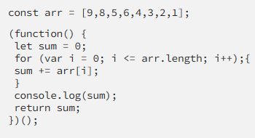

Answer: const arr = [9,8,5,6,4,3,2,1];

(function() {

let sum = 0;

for (var i = 0; i < arr.length; i++) {

sum += arr[i];

}

console.log(sum);

return sum;

})();

4.

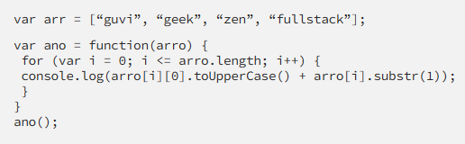

Answer:

var arr = ["guvi", "geek", "zen", "fullstack"];

var ano = function(arro) {

for (var i = 0; i < arro.length; i++) {

console.log(arro[i][0].toUpperCase()

+ arro[i].substr(1));

}

};

ano(arr);

5. 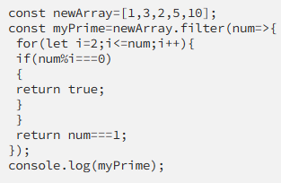

**Fix the code to return the Prime numbers**

const newArray = [1, 3, 2, 5, 10];

const myPrime = newArray.filter(num => {

for (let i = 2; i < num; i++) {

if (num % i === 0) {

return false;

} } return num !== 1;

});

console.log(myPrime);

6. **Fix the code to sum the number in that array:**

const num = [10, 20, 30, 40, 50, 60, 70, 80, 90, 100];

const add = (a, b) => a + b;

const result = num.reduce(add);

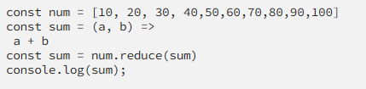console.log(result);

7.

**Fix the code to rotate an array by k times and return rotated array using IIFE function.**

var arr = [1, 2, 3, 6, 8, 6, 1, 9, 10, 12, 13];

var k = 3;

k = k % arr.length;

// Calculate the actual rotation value

(function() {

var out = arr.slice(k, arr.length).concat(arr.slice(0, k));

// Rotate the array using slice() and concat()

console.log(out);

})();

8. **Fix the code to gen Title caps.**

var arr = ["guvi", "geek", "zen", "fullstack"];

(function() {

for (var i = 0; i < arr.length; i++) {

console.log(arr[i][0].toUpperCase()

+ arr[i].substr(1)); }

})();

9. **print all odd numbers in an array using IIFE function**

var arr = [1, 2, 3, 5, 7, 79, 7, 2, 6, 9, 4];

(function() {

for (var i = 0; i < arr.length; i++) {

if (arr[i] % 2 !== 0) {

console.log(arr[i]);

}}

})();

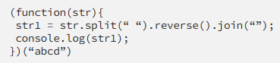**10.Fix the code to reverse.**

(function(str){

var str1 = str.split("").reverse().join("");

console.log(str1);

})("abcd");

11. **Fix the code to remove duplicates.**

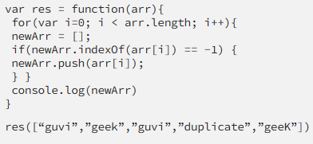var res = function(arr){

var newArr = [];

for(var i=0; i < arr.length; i++){

if(newArr.indexOf(arr[i].toLowerCase()) == -1) {

newArr.push(arr[i].toLowerCase());

}

}

console.log(newArr);

}

res(["guvi","geek","guvi","duplicate","geeK"]);

12.

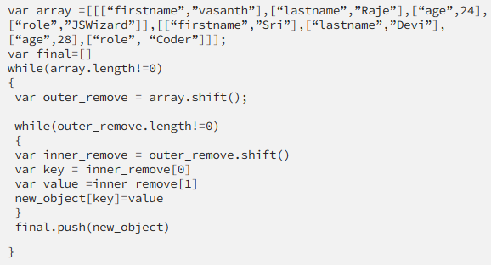

**Fix the code to give the below output:**

var array = [ [ ["firstname", "vasanth"],

["lastname", "Raja"],

["age", 24],

["role", "JSWizard"]

],

[ ["firstname", "Sri"],

["lastname", "Devi"],

["age", 28],

["role", "Coder"]

]

];

var final = [];

while (array.length != 0) {

var outer_remove = array.shift();

var new_object = {};

while (outer_remove.length != 0) {

var inner_remove = outer_remove.shift();

var key = inner_remove[0];

var value = inner_remove[1];

new_object[key] = value;

}

final.push(new_object);

}

console.log(final);

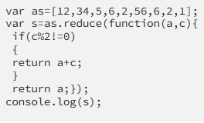**13.Fix the code to give the below output:**

**Sum of odd numbers in an array**

var as = [12, 34, 5, 6, 2, 56, 6, 2, 1];

var s = as.reduce(function(a, c) {

if (c % 2 != 0) {

return a + c;

}

return a;

});

console.log("The sum of odd numbers in the array is: " + s);

14.**Swap the odd and even digits**

const aa = data => {

let l = '';

for (let i = 0; i < data.length; i += 2) {

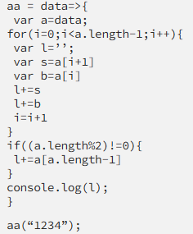 if (i < data.length - 1) {

l += data[i + 1];

}

l += data[i];

}

console.log(l);

};

aa("1234");